

|  |  |
| --- | --- |
| A network made up of connected lines and dots  Quantic  *an analytics company* | Week 7 - deliverables  This project addresses a vital organizational problem, ensuring alignment with business goals. It is guided by a structured lifecycle with a clear deadline, while a comprehensive data intake report safeguards data quality and relevance.  Ansel Vallejo | Data Scientist  LISUM25 |

QUANTIC

Table of Contents

**About Us1**

Quantic Team2

**Overview3**

Business Scope3

Data Intake Report4

**Problem Description5**

**Business Understanding6**

**Project Lifecycle7**

**References8**

Github Repo Link8

**i**

About Us

**Quantic** is an analytics company that places a strong emphasis on healthcare. We are dedicated to the idea that data can be a catalyst for positive change in the healthcare industry. With a talented team of data scientists and analysts, our primary objective is to tackle complex healthcare challenges and enhance patient outcomes. Our distinctive approach combines state-of-the-art data analytics with deep healthcare sector knowledge to deliver actionable insights, fostering informed decisions and meaningful advancements in healthcare provision. At Quantic, we are committed to a future where healthcare is not only data-driven but also healthier and more efficient.

**1**

Our Team



|  |  |  |  |  |
| --- | --- | --- | --- | --- |
| **Name** | **Email** | **Country** | **Institution** | **Specialization** |
| Ansel Vallejo | msavg@hotmail.com | Japan | Flatiron School | Data Science |

**2**

Overview



One of the persistent challenges faced by pharmaceutical companies lies in comprehending the duration of drug persistence as per physician prescriptions. To solve this problem, ABC Pharma Company recognized this issue and engaged Quantic to streamline and automate the identification process. By leveraging data analytics, the pharmaceutical company aimed to gain valuable insights into drug persistency patterns, ultimately enhancing their decision-making and ensuring better patient care. The collaboration between ABC Pharma and Quantic demonstrates a commitment to harnessing data-driven solutions to address critical industry challenges. Through this initiative, they strive to advance pharmaceutical practices and optimize patient outcomes.

Business Scope



The project scope entails the development of an automated system in collaboration with Quantic to analyze and identify drug persistency patterns within the pharmaceutical domain. This data-driven solution will enhance decision-making for ABC Pharma Company, ultimately leading to improved patient care and the advancement of pharmaceutical practices.

**3**

Data Intake Report

Name: *Healthcare_dataset*

Report date: *October 17th 2023*

Internship Batch: LISUM25

Version:1.0

Data intake by: Ansel Vallejo

Data intake reviewer: N/A

Data storage location: N/A

**Tabular data details:**

**City**

|  |  |
| --- | --- |
| **Total number of observations** | 3424 |
| **Total number of files** | 1 |
| **Total number of features** | 69 |
| **Base format of the file** | .CSV |
| **Size of the data** | 899 KB |

**Proposed Approach:**

* Check data for any missing values.
* Remove any unnecessary data.
* Uniformed formatting.
* Check for duplication.

**4**

Problem Description



The problem at hand is the challenge pharmaceutical companies face in comprehending the duration of drug persistency based on physician prescriptions. Understanding how long patients adhere to prescribed drug regimens is essential for improving treatment efficacy, patient outcomes, and pharmaceutical practices. The lack of an efficient and automated system for identifying persistency patterns has been a persistent obstacle in achieving these objectives.

**5**

Business Understanding



The core of our business understanding lies in recognizing the critical relationship between patient adherence to prescribed drug regimens and the effectiveness of pharmaceutical treatments. In the pharmaceutical industry, the ability to comprehend and improve drug persistency is not only vital for patient care but also influences the success of pharmaceutical products and practices.

**6**

Project Lifecycle

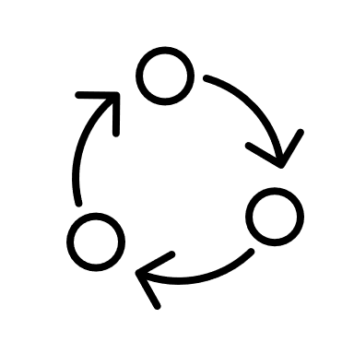

Final Project Report and Code

**November 30th 2023**

**7**

References



Github



<https://github.com/anvadev/Healthcare-Drug_Persistency>

**8**

**End of Documentation**



QUANTIC